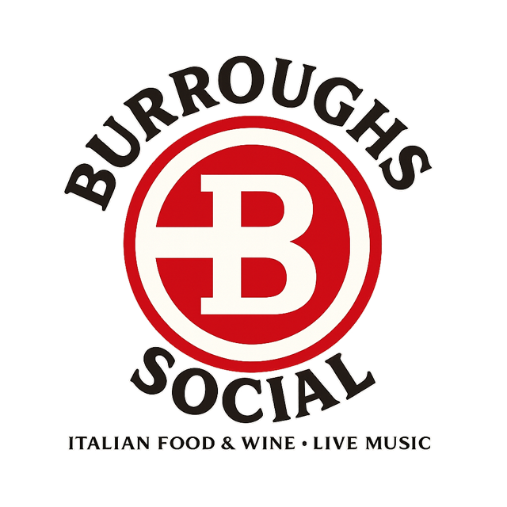
Procedures Manual

Contents
OVERVIEW 2
PATIO HOURS OF OPERATION 3
PATIO POLICIES 3
MAXIMUM OCCUPANCY 6
PARKING LOT SAFETY RULES 6
NEIGHBORHOOD ADVISORY BOARD (NAB) 6
ALCOHOL SAFETY PLAN 7

OVERVIEW
At this time, we are meeting with potential strategic partners who are local experienced restaurateurs, thus this procedures manual contains proposed minimal Standard Operating Procedures (SOPs) and is subject to change.

For now, we will refer to the entertainment area of the property as Burroughs Social. Burroughs Social is projected to be a casual yet classy historical venue open to the public with opportunities for private event rentals.

This manual establishes potential standardized procedures for safety, lawful, and consistent operation of Burroughs Social. It ensures:

- Compliance with local ordinances and licenses
- High standards of hospitality and safety
- Prioritize consistent guest experience and business operations
- Positive neighbor relations

PATIO HOURS OF OPERATION
Peak-Season
May 1st – September 15th

Monday - Closed
Thursday – Saturday – Open to the Public
4pm - 930pm*

Friday and Saturday
*Live music - 4pm-930pm

Sunday Brunch
10am - 2pm

Sunday, Tuesday, Wednesday – Private Events only
4pm – 930pm

Off-Season
September 16th – April 30th
Closed for the season.

PATIO POLICIES
The patio is available to the public during normal business hours and will be monitored at all times. Additionally, the patio can be rented for private events through the manager or event coordinator (if available).

General Rules
- Management reserves the right to remove anyone from the patio at any time.
- Furniture will be arranged to maintain clear walkways.
- No standing crowds blocking exits.
- Patio will be closed during unsafe weather conditions as deemed by the manager on duty (see outdoor event contingency plan section for details).
- Sound levels will be monitored continuously for compliance with local ordinance using a decibel meter per the Monitoring paragraph below (all amplified music is required to plug into our sound system, where the maximum output levels will be preset).
- Patio will be cleaned at the close of each business day and deep cleaned on Mondays.
- No external lighting, personal lighting bars, strobe lights, or any other entertainment lights authorized. Burroughs Social reserves the right to disconnect any unauthorized electrical equipment immediately.

Music Types
Ambient music, live music (with low amplification) (acoustic, violin, jazz, duos ONLY – NO DJs or Bands of 3 pieces or more)
Strict Noise Rules
All outdoor music (ambient or live) on the patio WILL NOT exceed 65 decibels at any time (measured at the property line or nearest residential boundary using decibel meter).

Burroughs Social sound equipment is designed with controlled limits making it impossible to exceed the allowable limits.
No outdoor music permitted after 930pm regardless of event type.

Monitoring
Visible decibel monitor will be installed.
Manager will check decibel levels hourly within the venue and at the property line on Brighton Road and log them into a daily report.
Volume must be controlled by the staff, not the hired musicians.

Private Events (a staff manger will be present for all private events)
The sound system is available for use during private events with the approval of a manager and will be controlled by Burroughs Staff at all times during the event. (This is required for any amplified music)
All performers must be approved by management in advance.
No additional sound equipment or amplification is permitted on the property.
No external lighting sources or equipment are authorized.
No extended hours are authorized.

Private Event Contract-Enforcement
All patio events require a signed agreement acknowledging:
  - Event Type and Details
  - Fees and Payment
  - Cancellation and Refund Policy
  - Insurance and Liability
  - Rules and Compliance
  - Management Authority
  - Entertainment/Sound Limits
  - Clean-up Protocol
  - Neighborhood Consideration Clause
  - Additional Terms

The following note will be added to each contract:

Note: As this property is located near residential neighborhoods, we are committed to being respectful community partners while providing a great guest experience and ask your assistance by adhering to the sound rules.

Management reserves the right to terminate any private event that violates the sound rules, creates public safety concerns, or generates multiple neighborhood complaints.

Outdoor Event Contingency Plan
In the event of severe weather, Burroughs will make reasonable efforts to relocate the event indoors or reschedule (no refunds authorized due to weather or any other force majeure (acts of God, government restrictions)). If an alternative location is provided no refund will be issued regardless.

Clean-up (both private and public events)

The patio will be cleaned immediately after each event and at the full close of each business day.

Cleaning procedures will be detailed in the employee guide and within private event contracts as applicable.

End-of-Night Quiet Clean-up
To respect nearby residents:
- No dragging furniture
- No loud conversations or music
- No glass dumping after 9:30pm
- Staff voices kept low and professional

MAXIMUM OCCUPANCY
Overall Occupancy Load (per fire code/posted signs):
Patio: 130

PARKING LOT SAFETY RULES
Burroughs Social parking lot includes a shared easement with Oak Pointe Country Club which consists of 88 total spaces per the proposed site plan, 84 standard spaces and four barrier free spaces. Per Section 14.04 of the local zoning ordinance, 64 spaces are required.

To ensure safe vehicle/pedestrian circulation, prevent blocking of aisles/driveways/emergency routes, and comply with off-street parking standards in Zoning Ordinance Article 14, the following rules are in place:

All vehicles, including (but not limited to) automobiles, delivery vehicles, and low-speed vehicles such as golf carts, MUST park in designated, marked parking spaces ONLY.

No parking on grass, landscaped areas, drive aisles, fire lanes, sidewalks, along the street, or other non-designated surfaces.

Golf carts and similar low-speed vehicles (utility carts used by patrons, staff, or for event support) are prohibited from idling, driving, or parking in non-parking areas, including near patio entrances/exits, pedestrian paths, or loading zones, to minimize conflicts with foot traffic and ensure clear emergency access.

Clear signage will be posted at all times at parking lot entrances and key areas stating, “All vehicles, including golf carts, must park in designated spaces only. Violators subject to towing/removal at owners’ expense”.

Burroughs Social staff will monitor the parking lot during all business hours to enforce these rules and immediately report any violations to appropriate channels.

NEIGHBORHOOD ADVISORY BOARD (NAB)
Burroughs Social will maintain a five-person Neighborhood Advisory Board (NAB) to ensure accountability as a community partner within Genoa Township.

The five-person panel will consist of voluntary members who provide direct feedback on Burroughs operations, help brainstorm community events, and ensure growth aligns with the character of the surrounding area. All feedback provided will be taken seriously and used to improve operations where applicable.

The commitment is one 60-minute meeting per quarter with perks consisting of meal discounts throughout the year. Members serve a one-year term to ensure diverse perspectives over time.

Mission Statement: The Burroughs Social Neighborhood Advisory Board exists to foster open dialogue, ensure local accountability, and create a collaborative bridge between our business operations and the residents of Genoa Township. We aim to grow sustainability while remaining a respectful and contributing neighbor.

NOTE: The NAB is advisory in nature, not governing, and provides vital recommendations that inform ownership’s final decisions.

ALCOHOL SAFETY PLAN
Burroughs Hospitality Group, LLC Alcohol Safety Plan Introduction
As an on-premises holder of Class C and SDM licenses issued by the Michigan Liquor Control Commission (MLCC), Burroughs Hospitality Group, LLC is committed to responsible alcohol service, guest safety, and full compliance with MLCC regulations, Michigan Liquor Code (MLC) 436, local Genoa Township ordinances, and best practices for welcoming, community-oriented environment for patrons.

Responsible Alcohol Service Policy
This policy applies to all staff, managers, contractors, event coordinators, and event hosts. All team members receive training upon hire and annual refreshers in accordance with applicable laws and regulations. Training certificates will be kept on file.

Burroughs Social Priorities:
- Preventing service to minors (under 21 years of age)
- Avoiding over-service and intoxication
- Ensuring safe premises (including indoor bar, outdoor patio, and rentable workspace)
- Promoting a positive, inclusive neighborhood environment

No service to minors: All patrons appearing under 40 years of age must present valid government-issued photo ID (driver’s license, passport, military or state ID). Acceptable forms must show date of birth and photo. NO EXCEPTIONS.

Staff will be trained to check for fake identification. If suspicious, staff will politely decline service and report to the manager on duty.

Supervisory Requirement
At least one MLCC-approved server-trained supervisor must be on duty during all hours (MCL 436.1501).

Guest and Outdoor Premises Safety Pertaining to Alcohol
The outdoor service area (OSA) will be enclosed by a split rail wooden fence which forms a complete barrier around the perimeter of the patio/outdoor service area. The wooden fence is approximately 48” high and completely encloses the area.

The OSA is staffed by employees and can only be accessed through the interior of Burroughs Social. During private events, the OSA remains accessible only through Burroughs Social and will require at least one staff member and a manager in attendance at all times.

All alcoholic beverages must be purchased from Burroughs Social. No outside beer, wine, or liquor is permitted.

Clear signs will be displayed at each exit of the OSA stating, “no alcohol is to be removed from the premises/NO ALCOHOL BEYOND THIS POINT.”

No unaccompanied minors are allowed on the premises.

The liquor license will be prominently displayed.

Any license violations by staff will result in immediate termination.

Intoxicated customers will be removed from the premises.

Employees should be attentive to common signs of intoxication, which may include:
- Loud or Slurred Speech
- Drinking Fast
- Stumbling
- Overly Friendly Behavior
- Sleepiness
- Glassy or Bloodshot Eyes
- Inability to Complete Sentences

Employees should make reasonable efforts to ensure all intoxicated patrons have access to safe transportation and should make reasonable efforts to prevent intoxicated patrons from driving.

